Clone Assignment:-
Assignment 1: Base Table Analysis
- Load both datasets into Snowflake tables
- Validate row counts and data distribution
- Identify candidate tables for cloning
- Explain why these tables are suitable for cloning experiments

Load both datasets into Snowflake tables
• Loaded both datasets into Snowflake tables.
SELECT * FROM EMPLOYEES;
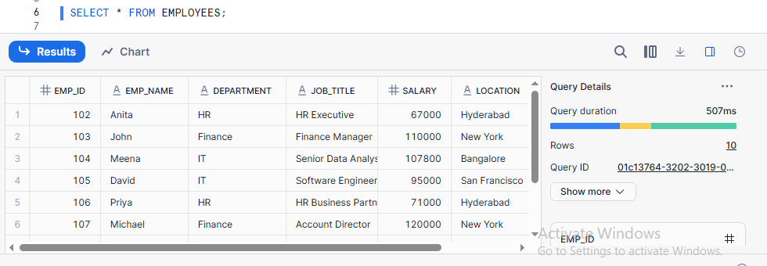
SELECT * FROM DEPARTMENT;

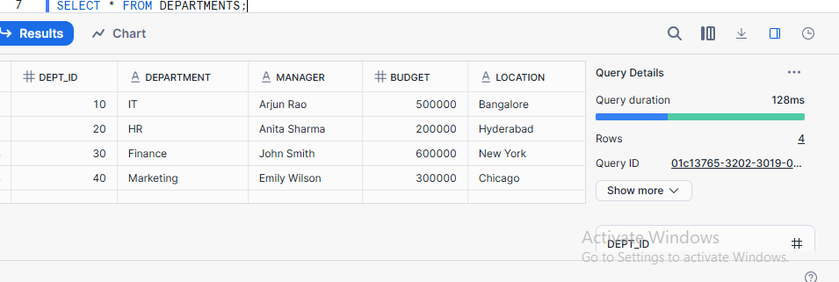
Validate row counts and data distribution
SELECT COUNT(*) AS EMPLOYEES_COUNT FROM EMPLOYEES;

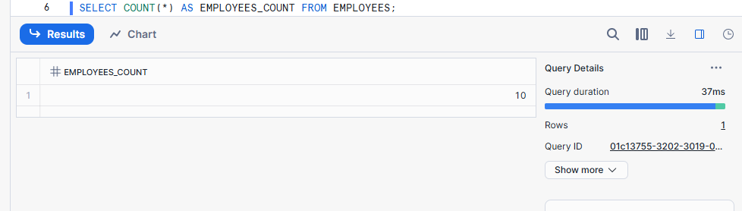
SELECT COUNT(*) AS DEPARTMENTS_COUNT FROM DEPARTMENTS;
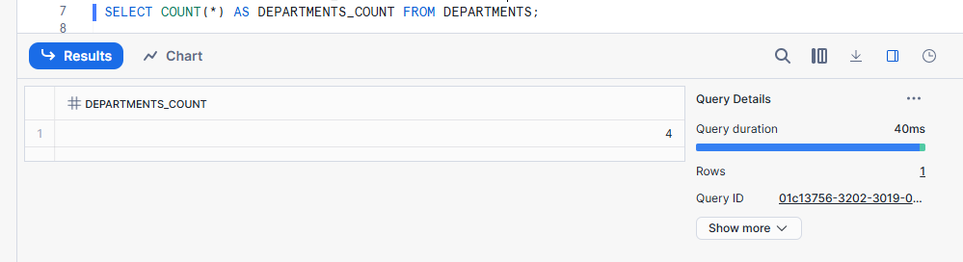
Identify candidate tables for cloning
Candidate tables for cloning are large, frequently used tables that need to be copied for testing or analysis without affecting production data.

Explain why these tables are suitable for cloning experiments
The suitability of selected tables for cloning experiments based on data size, structure, and testing requirements

Assignment 2: Table-Level Cloning
Performed table-level cloning to create zero-copy copies of selected tables for testing and validation.
Zero_copy:- Zero copy is a method where data is shared, not duplicated, when creating a clone.
- Clone the employee table
CREATE OR REPLACE TABLE EMPLOYEES_CLONE CLONE PUBLIC.EMPLOYEES;
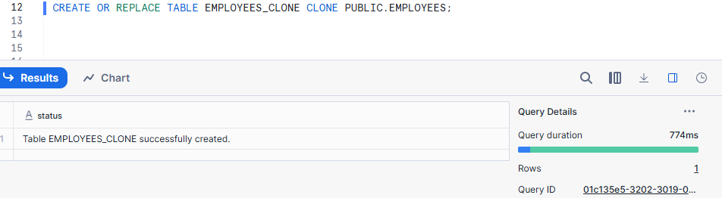
- Compare:
  - Row count
Select Count(*) from employees;
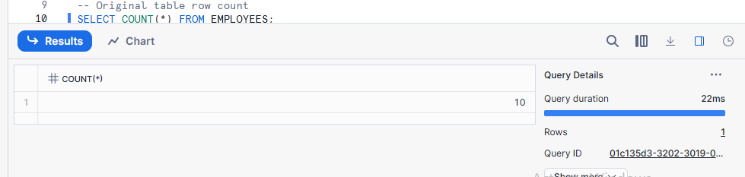
Select Count(*) from employees_ clone;
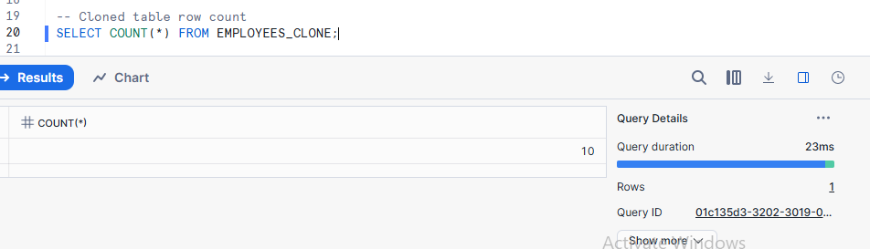
  - Query performance
-- Query on original table

SELECT DEPARTMENT, COUNT(*)
FROM EMPLOYEES
GROUP BY DEPARTMENT;

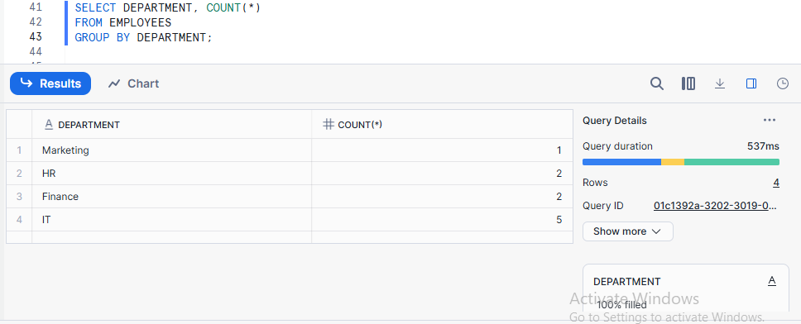
-- Query on cloned table
SELECT DEPARTMENT, COUNT(*)
FROM EMPLOYEES_CLONE
GROUP BY DEPARTMENT;
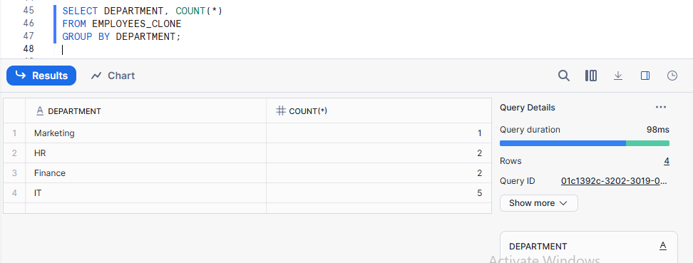
  - Storage usage
SELECT
table_name,
bytes,
row_count
FROM information_schema.tables
WHERE table_name IN ('EMPLOYEES', 'EMPLOYEES_CLONE');

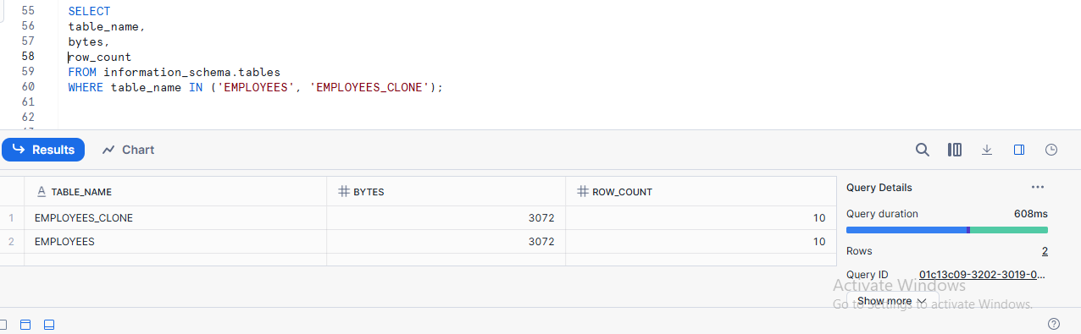
Explain why clone creation is instantaneous
Table cloning in Snowflake is fast because it shares data storage and copies only metadata.

Assignment 3: Change Isolation Testing
Change isolation ensures that changes made in a clone or original do not affect each other.
- Update salary data in the original employee table
UPDATE EMPLOYEES
SET SALARY = SALARY + 5000
WHERE EMP_ID = 101;
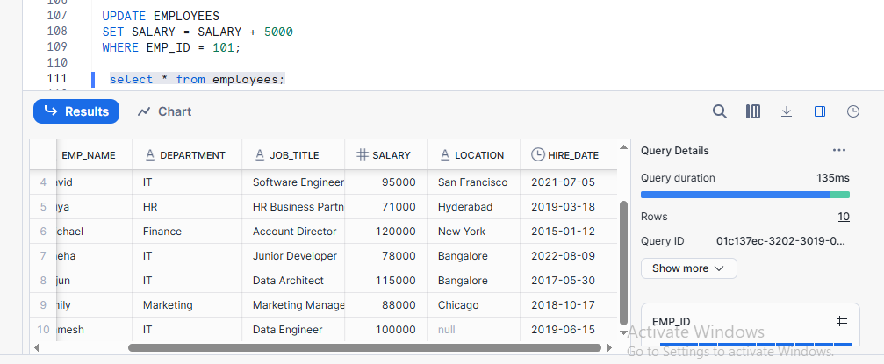

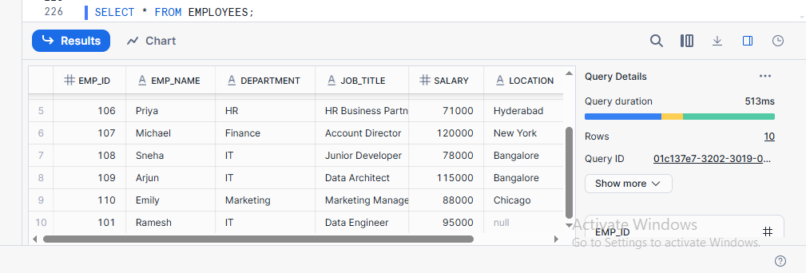
- Delete records in the cloned table
DELETE FROM EMPLOYEES_CLONE
WHERE EMP_ID = 101;

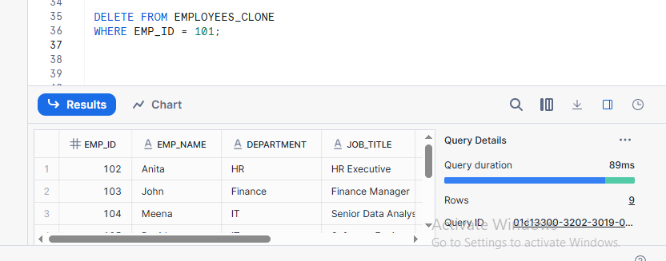
- Insert new records in the clone
INSERT INTO EMPLOYEES_CLONE VALUES
(101, 'Ramesh','IT','Data Engineer',95000,'Bangalore','2019-06-15');
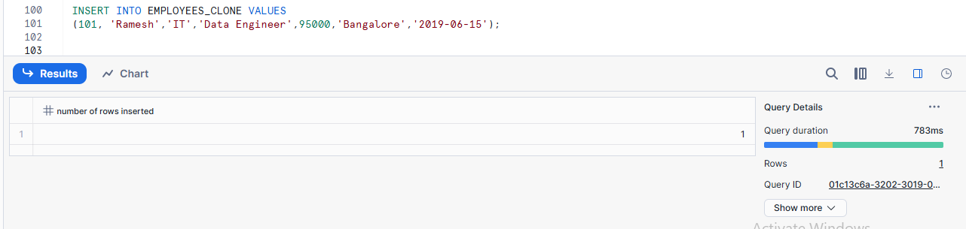

- Validate isolation between original and clone
Isolation between original and clone means changes made in the original table (update, delete, insert) do not affect the cloned table, and changes made in the clone do not affect the original table.

-- Row count comparison
SELECT COUNT(*) FROM EMPLOYEES;
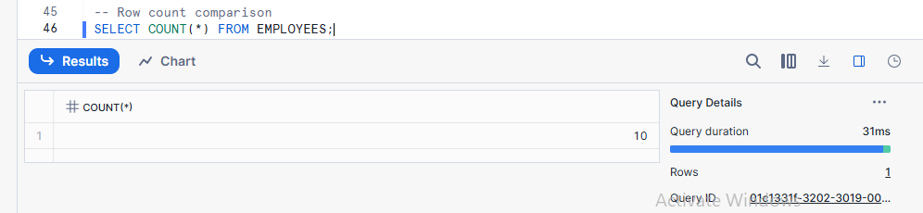

SELECT COUNT(*) FROM EMPLOYEES_CLONE;
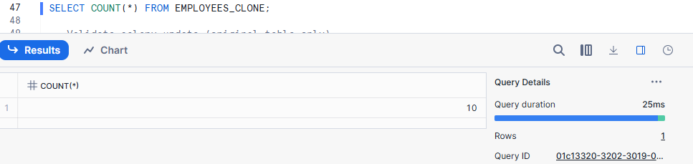

-- Validate salary update (original table only)
SELECT EMP_ID, SALARY
FROM EMPLOYEES
WHERE EMP_ID = 101;
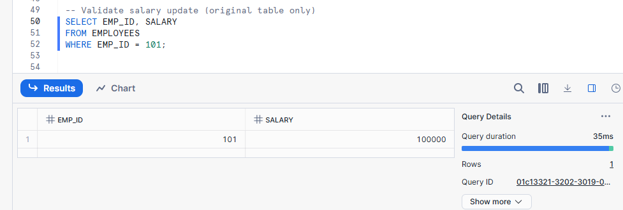
-- Validate delete and insert (clone only)
SELECT * from employees_clone;

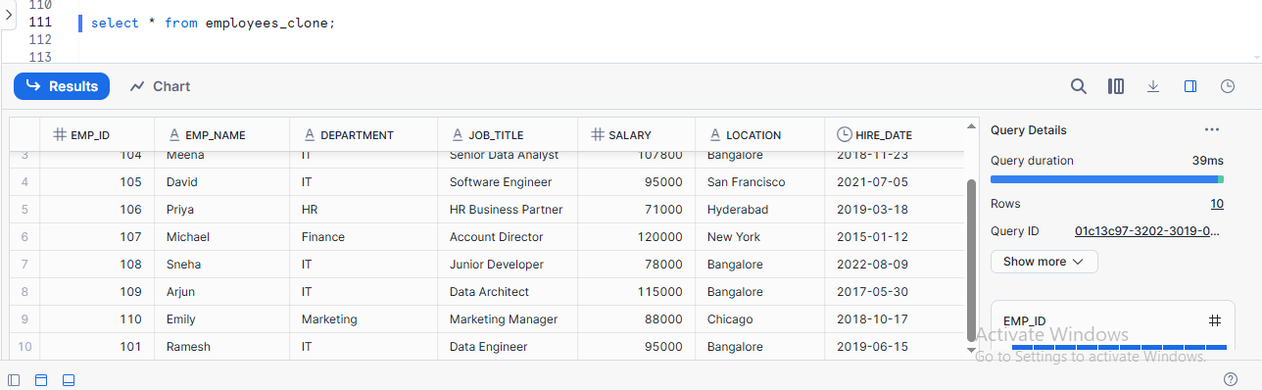

Delete from employees_clone Emp_id =101;
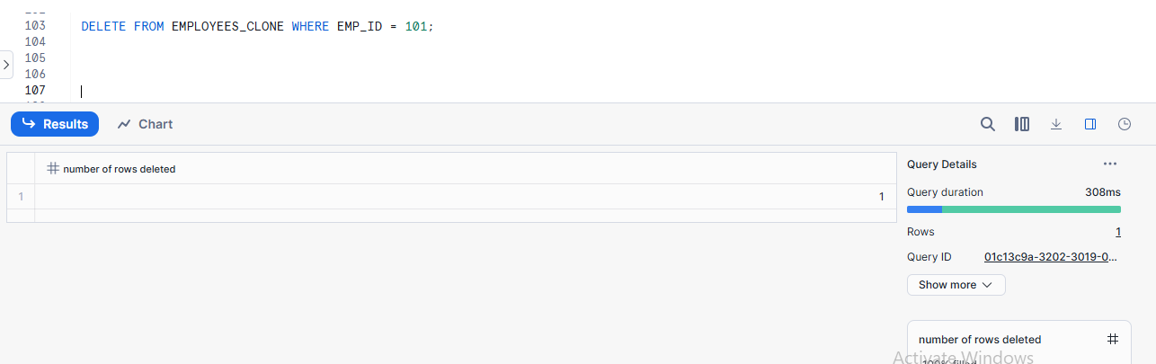
Insert Into:-
INSERT INTO EMPLOYEES_CLONE VALUES
(101, 'Ramesh','IT','Data Engineer',95000,'Bangalore','2019-06-15');
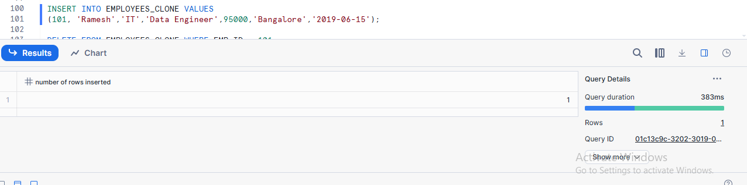

Explain backend copy-on-write behaviour
Copy-on-write means data is shared between the original and clone until a change is made, after which only the changed data is copied.

Assignment 4: Storage Growth Exploration
Storage increases when you insert, update, or delete data.
- Perform DML operations incrementally
Insert Operation:-
INSERT INTO EMPLOYEES
VALUES (201, 'Anita', 'HR', 'Manager', 65000, 'Chennai', '2021-05-10');
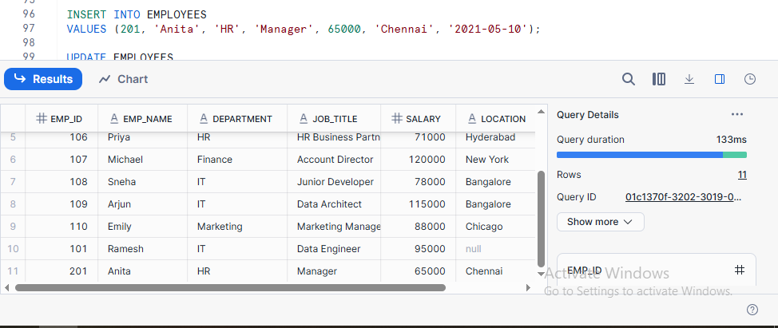
Update Operation:-
UPDATE EMPLOYEES
SET SALARY = SALARY + 5000
WHERE EMP_ID = 105;
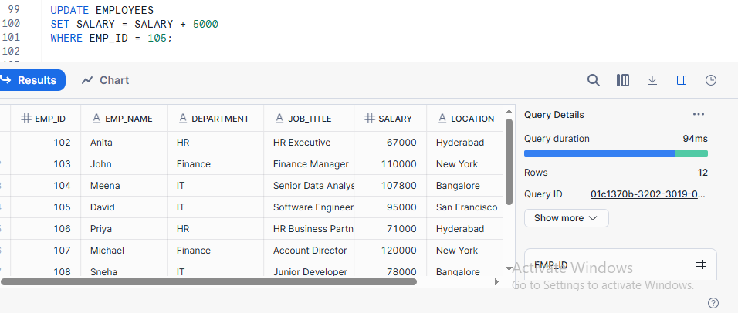

DELETE operation:-
DELETE FROM EMPLOYEES WHERE EMP_ID = 201;

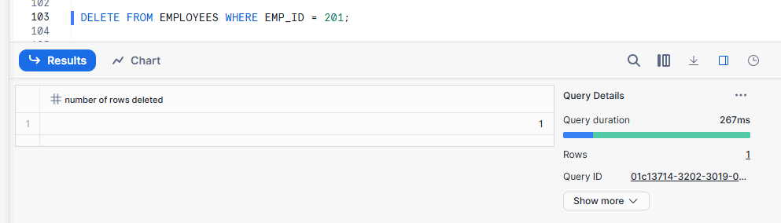

- Track storage before and after each operation
Track storage before and after each operation means comparing storage usage before and after changes.
- Identify the exact moment storage increases
Storage increases immediately after INSERT, UPDATE, or DELETE operations that modify data.

- Explain Snowflake’s physical storage strategy
Snowflake saves data in small blocks and handles storage automatically.

Assignment 5: Time Travel Cloning
Time Travel Cloning creates a copy of data as it was at a past time without duplicating all storage.
- Perform multiple updates on the original table
--Update salaries multiple times
UPDATE EMPLOYEES SET SALARY = SALARY + 1000 WHERE EMP_ID = 102;
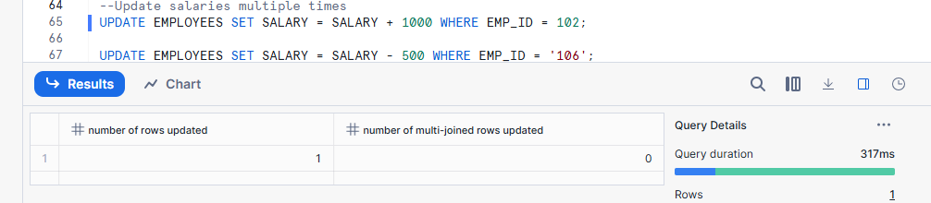

UPDATE EMPLOYEES SET SALARY = SALARY - 500 WHERE EMP_ID = '106';
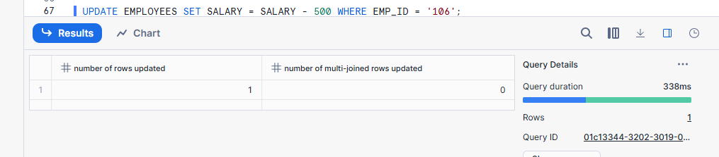

- Create clones from:
  - Current state
CREATE TABLE EMPLOYEES_CLONE_CURRENT CLONE EMPLOYEES;
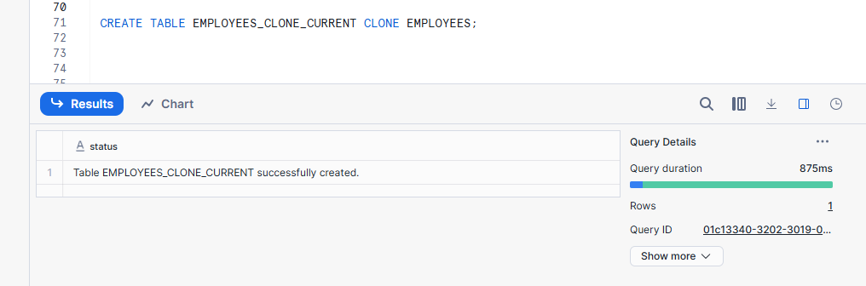
  - Past state (Time Travel)
CREATE TABLE EMPLOYEES_CLONE_PAST CLONE EMPLOYEES AT (OFFSET => -7200);
OffSET:- how many seconds to go back from the current time.
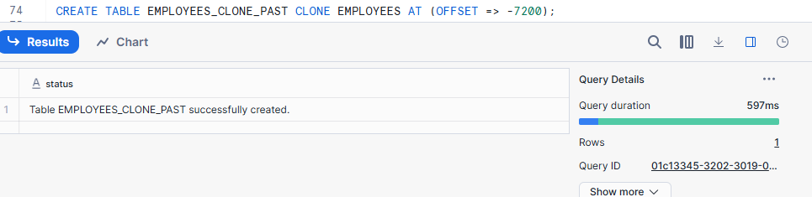
- Compare data across versions
-- Compare original vs current clone
SELECT * FROM EMPLOYEES
MINUS
SELECT * FROM EMPLOYEES_CLONE_CURRENT;
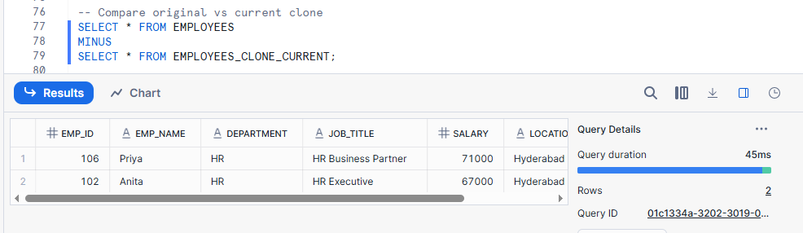

-- Compare original vs past clone
SELECT * FROM EMPLOYEES
MINUS
SELECT * FROM EMPLOYEES_CLONE_PAST;
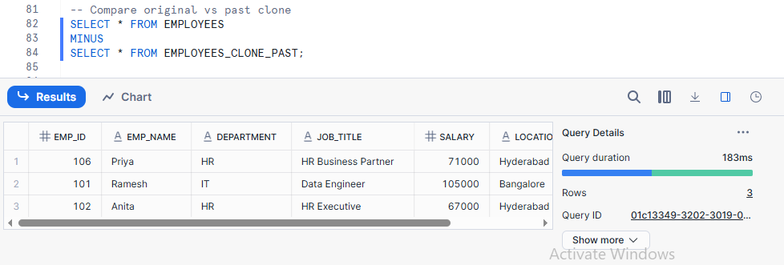

- Explain real-world recovery use cases
Time Travel lets you recover or view past data easily.

Assignment 6: Schema-Level Cloning
Schema cloning copies a schema without using extra storage.
- Clone a schema containing employee and department tables

Create schema HR_CLONE CLONE HR;

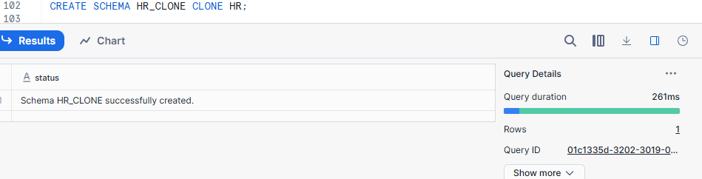

- Modify tables in cloned schema

UPDATE employees
SET salary = salary * 1.1 (salary * 1.1 → increases the salary by 10%.)
WHERE emp_id = 104;

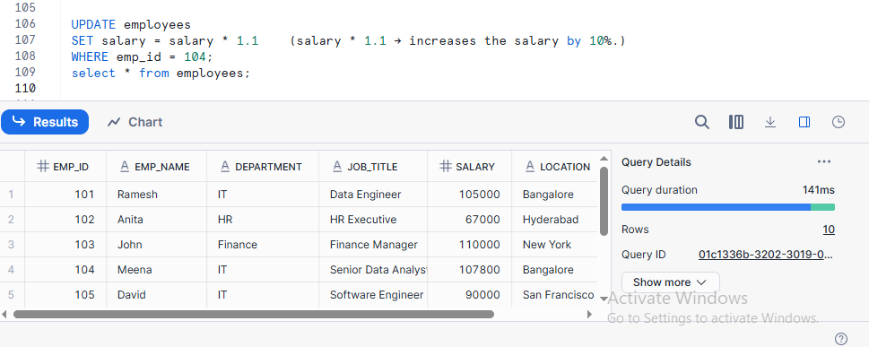

Insert into employees (emp_id, emp_name, department, salary,hire_date) values (101, ‘john Doe’, 20, 5000,’2025-12-21’);

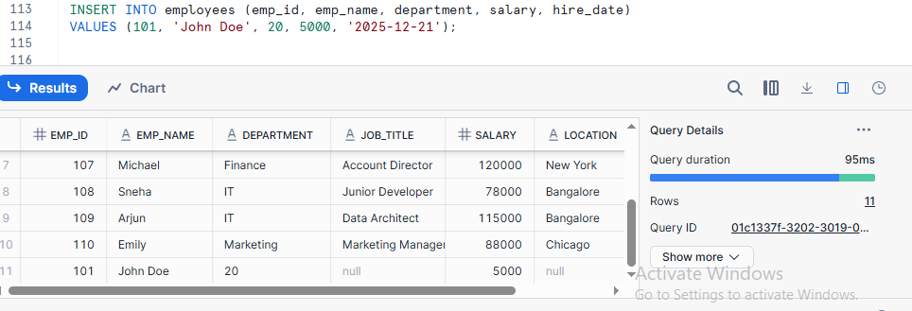

delete from employees where emp_id =101;

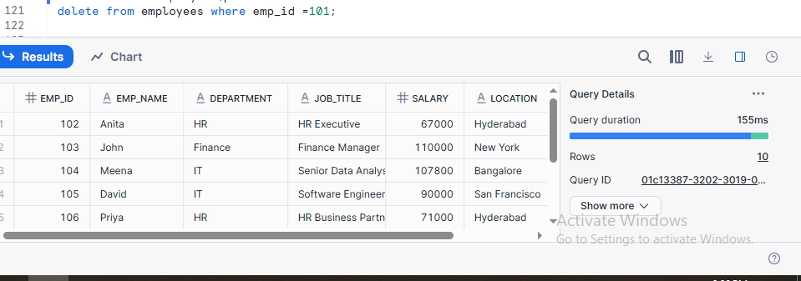

- Drop tables in original schema
Drop table employees;

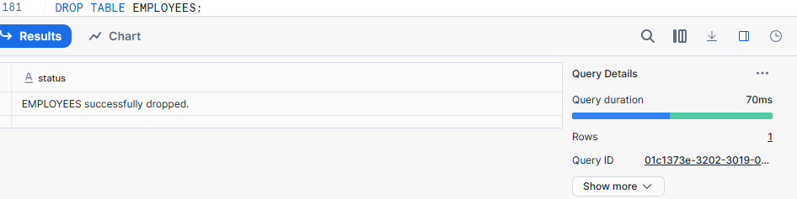

Drop table departments;
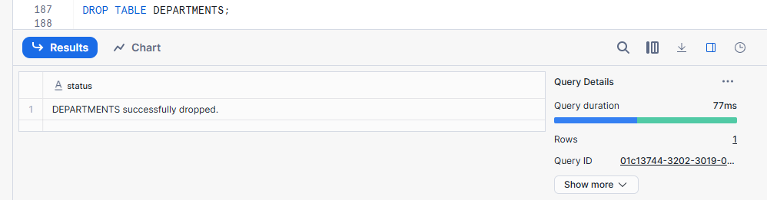
- Observe behavior and explain metadata inheritance

Cloned objects inherit the original’s metadata, but data changes remain separate.

Inheritance:- Inheritance is when a new object takes the structure and properties of an existing object.

Assignment 7: Database-Level Cloning
- Clone the entire database
CREATE DATABASE HR_DB_CLONE CLONE HR_DB;

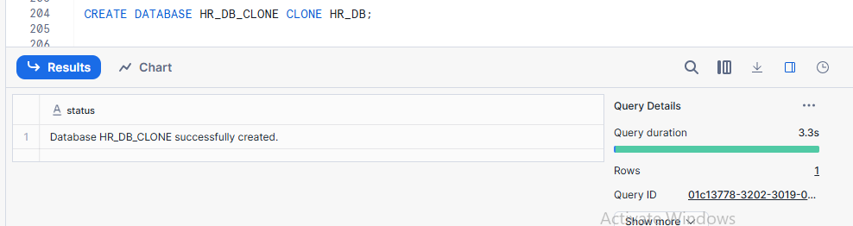

- Test query access and object availability

Test Query:-

SELECT COUNT(*)
FROM HR_DB_CLONE.PUBLIC.EMPLOYEES;

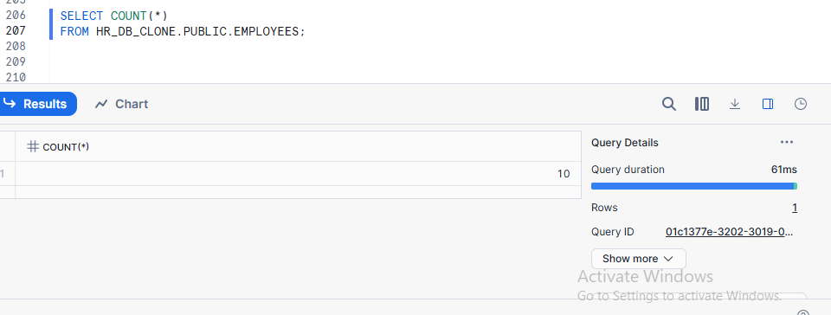
Object availability:-

- Perform DML on cloned database

-- Insert new record
INSERT INTO EMPLOYEE (EMP_ID, EMP_NAME, DEPT, SALARY)
VALUES (101, 'John Doe', 'IT', 75000);

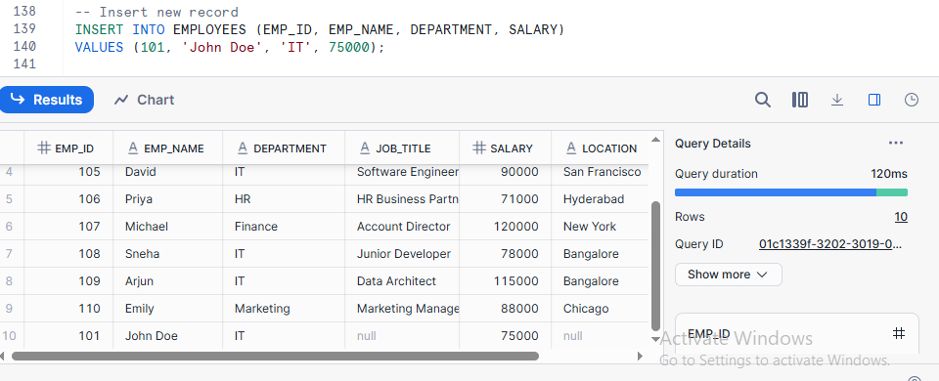

-- Update record
UPDATE EMPLOYEE SET SALARY = 80000 WHERE EMP_ID = 101;

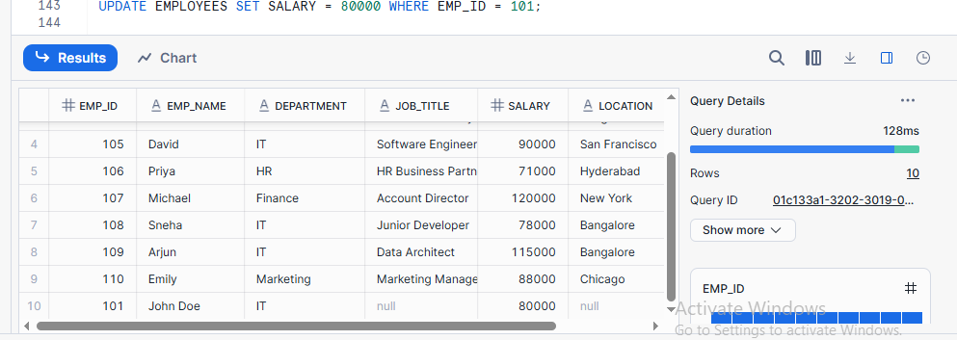

-- Delete record
DELETE FROM EMPLOYEE WHERE EMP_ID = 101;

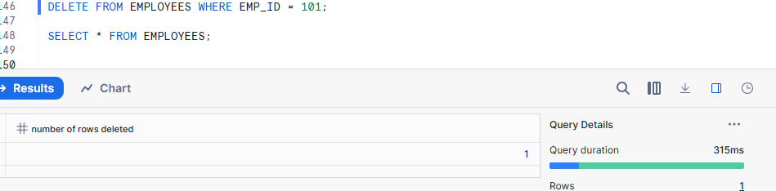

- Explain how Snowflake isolates environments (Dev/Test/Prod)

Snowflake isolates Development , Test, and Production by using separate databases or clones, where each environment has its own data changes while sharing metadata and storage efficiently.

Assignment 8: Privileges & Security
Privileges & Security mean controlling who can access data and what actions they are allowed to perform (view, insert, update, delete).
- Analyze access privileges before cloning

SHOW GRANTS ON TABLE EMPLOYEES;

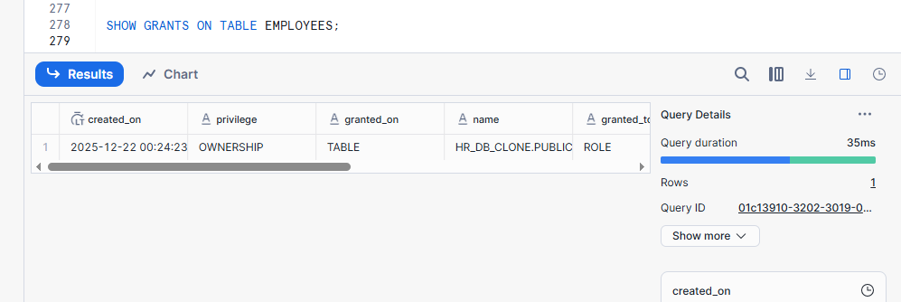

CREATE TABLE EMPLOYEES_CLONE
CLONE EMPLOYEES;

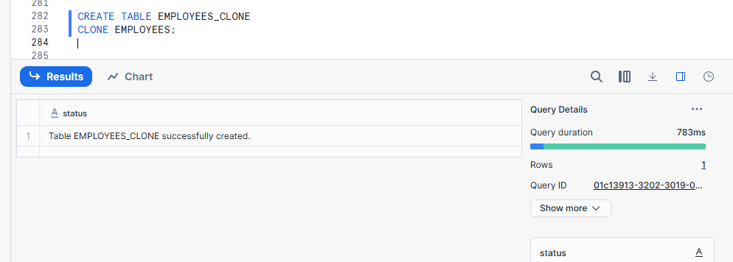

- Observe privileges after cloning

SHOW GRANTS ON TABLE EMPLOYEES_CLONE;

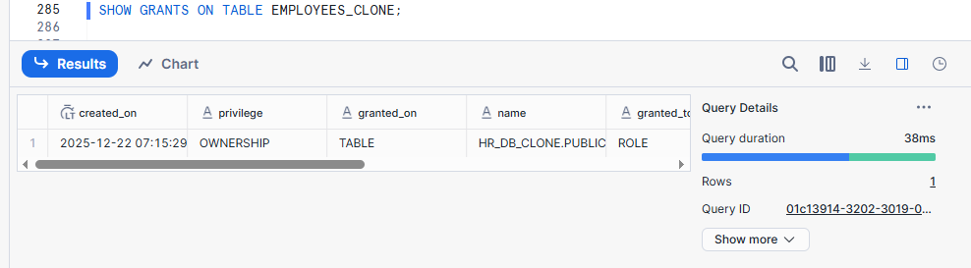

- Modify privileges on clone
GRANT SELECT
ON TABLE EMPLOYEES_CLONE
TO ROLE ANALYST_ROLE;

(Analyst_role is a read only used to analyze data without modifying it)

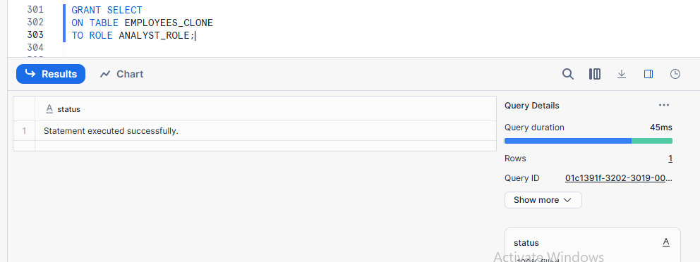

- why Snowflake handles security this way
Snowflake isolates security so cloned environments can have independent access control without impacting production.

Assignment 9: Performance Comparison
Performance Comparison means checking and comparing how fast queries run, how much resources are used, or how efficiently data is processed across different environments or objects.
- Run identical analytical queries on:
- Original tables
SELECT
DEPARTMENT,
COUNT(*) AS EMP_COUNT,
AVG(SALARY) AS AVG_SALARY
FROM EMPLOYEES
GROUP BY DEPARTMENT;
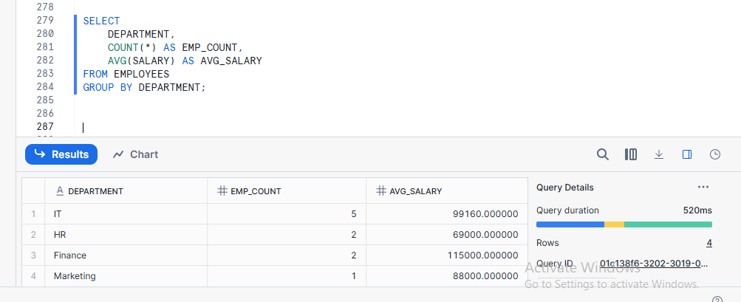

- Cloned tables
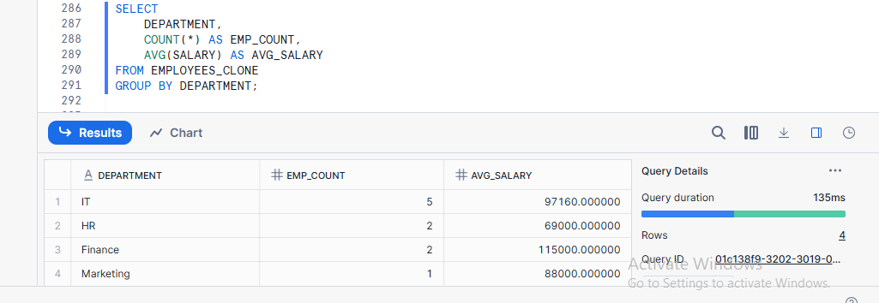

- Compare execution plans
Execution plans are compared to evaluate query efficiency

Original Table

EXPLAIN USING TEXT
SELECT
department,
AVG(salary)
FROM employees
GROUP BY department;

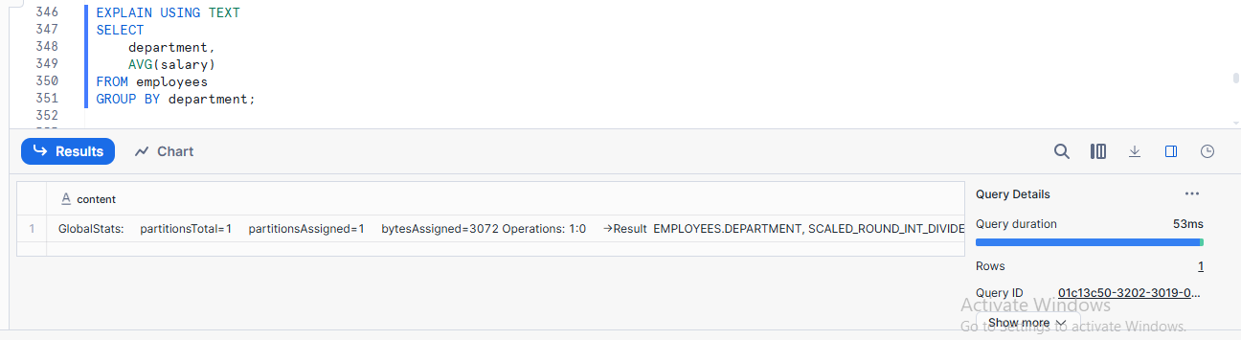

Clone Table
EXPLAIN USING TEXT
SELECT
department,
AVG(salary)
FROM employees_clone
GROUP BY department;
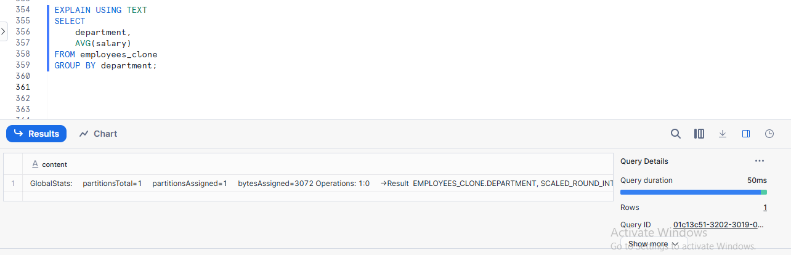
- Explain performance similarities/differences
Original and cloned tables show similar performance because Snowflake cloning shares the same physical data; any minor differences are due to caching or workload, not data duplication.

Assignment 10: Cleanup & Retention

- Drop original objects
Drop table employees;
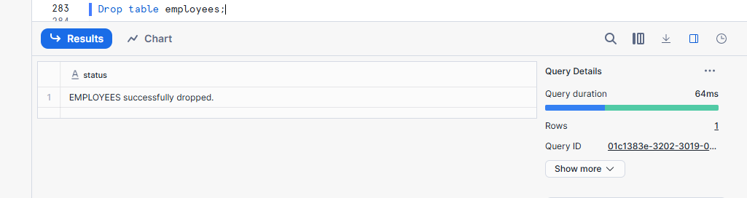
- Validate cloned object availability
SELECT COUNT(*) FROM EMPLOYEES_CLONE;
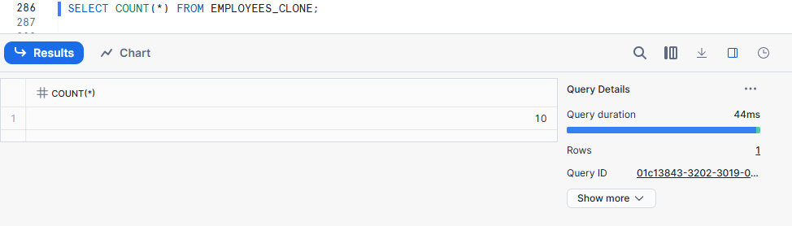
- Drop clone and analyze Time Travel behaviour
SELECT * FROM EMPLOYEES
AT (TIMESTAMP => CURRENT_TIMESTAMP - INTERVAL '5 MINUTE');
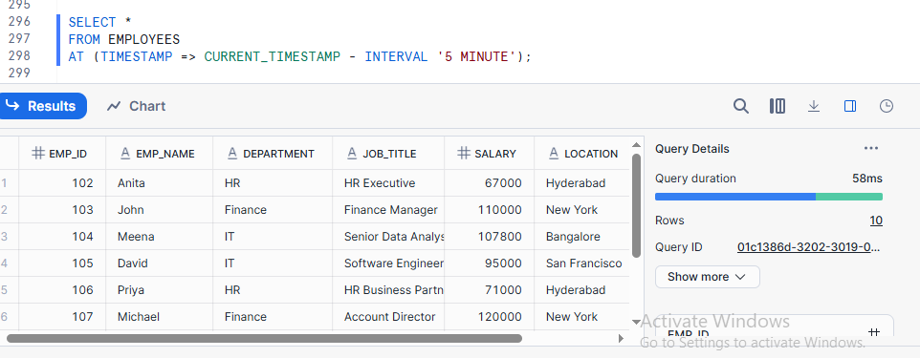
- Explain lifecycle and retention rules
After an object is dropped, Snowflake keeps it in Time Travel for recovery, then in Fail-safe, and finally deletes it permanently.

